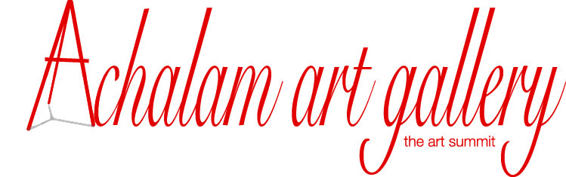

No.979, Lakshmanaswamy salai, K.K.Nagar, Chennai – 600 078.
Email : achalamartgallery@gmail.com / website: www.achalamartgallery.com
Ph: (044)42127682 / 9381024002 / 7358656712

Scheme 1
To
(Name of Artist)

Achalam art gallery congratulates and welcomes you to this project.
Our gallery takes many order works and hence require dedicated artists to execute them. We wanted to give this opportunity to the deserving artists and hence chose you as one of our artists to do the work. We have collected from you an amount of Rs.50, 000/- vide -----Bank ch.no.------/ online transfer / by cash towards deposit for the order work. This contract is for One year and can be terminated with a prior notice period of one month. In such case Rs.45, 000/- will be returned.

(V.Mahalakshmi) (Signature of Artist)
Director
Achalam art gallery

Terms and conditions
- Paintings of various sizes will be given. The total deposit is Rs.50,000/-. Rs.4,500 worth painting will be given every month.
- Artists can directly start off with the order works. Learners should undergo three months training . Materials will be provided by us to practise two canvas boards of A3 size.
- For order work Paintings a maximum time of two months can be taken to complete each painting.
- The material cost will be deducted from the payment. For example if the cost of painting is 4500/- and the material cost is 1,000/- then Rs.3,500/- will be paid.
- Artists can choose their pictures to paint.
- Paintings done here will be provided with materials like colour etc. But in case of taking home, no colours will be given, instead a fixed amount will be paid for the colours.
- Masters guidance can be had in the timings 9am to 11 am and 4 pm to 6 pm on all the days.
- Call and confirm Master’s availability to get the guidance.
- The painting should be perfectly finished and completed to the expectation of the client. Only then payment will be released for that particular painting.
- Payment will not be released if the paintings are not completed with the given time.
- To drop out from the project and to get the deposit refund a notice period of at least one month is essential.
- The contract is valid for one year. It can be renewed for another one year.
- Bonus of 4 % of the deposit amount will be paid for referring a person to this project.
- The paintings done by you will be used for any purpose like selling, rental, display etc.
- If the work is not satisfactory or not completed before the fixed date payment will not be given and even the contract may be cancelled for that particular artist and the deposit returned.
- Artists should bring their own brushes, palette and waste cloth to do paintings.
- The refund amount at any time will be Rs.45,000/- only.

(S.Venkatachalapathy) (Signature of Artist)
Director
Sri Annai Kamakshi Kalaikudam

